Beaconhouse National University School of Computer & Information Technology
LAB ASSIGNMENT 4: Static & Dynamic NAT Configuration
Course | Computer Networks Lab (Lab-209) | Marks | 20 Marks
Semester | Spring 2026 | CLO | CLO 4 (Apply - C3)
Instructor | Shazia Rizwan | Lab Instructor | Hasnain Ahmad

Student Name: Saad Mughal Roll No: F2023-009
1. Learning Objectives
- Build a multi-router infrastructure simulating a Private LAN and a Public ISP.
- Configure Static and Dynamic NAT to resolve private-to-public IP translation.
- Implement Default Routing and Return Path Routing for end-to-end pings.
- Differentiate between Inside Local, Inside Global, and Outside Global addresses.
2. Lab Topology & Addressing
Construct the network with 3 PCs, a Switch, R1, INTERNET Router, and a Google Server.
Device Interface IP Address Subnet Mask Default Gateway
PC1 / 2 / 3 | NIC | 172.16.0.1, .2, .3 | 255.255.255.0 | 172.16.0.254
R1 (LAN) | G0/1 | 172.16.0.254 | 255.255.255.0 | N/A
R1 (WAN) | G0/0 | 203.0.113.1 | 255.255.255.252 | N/A
INTERNET | G0/0 | 203.0.113.2 | 255.255.255.252 | N/A
INTERNET | G0/1 | 8.8.8.1 | 255.255.255.0 | N/A
Google Server | NIC | 8.8.8.8 | 255.255.255.0 | 8.8.8.1

Topology

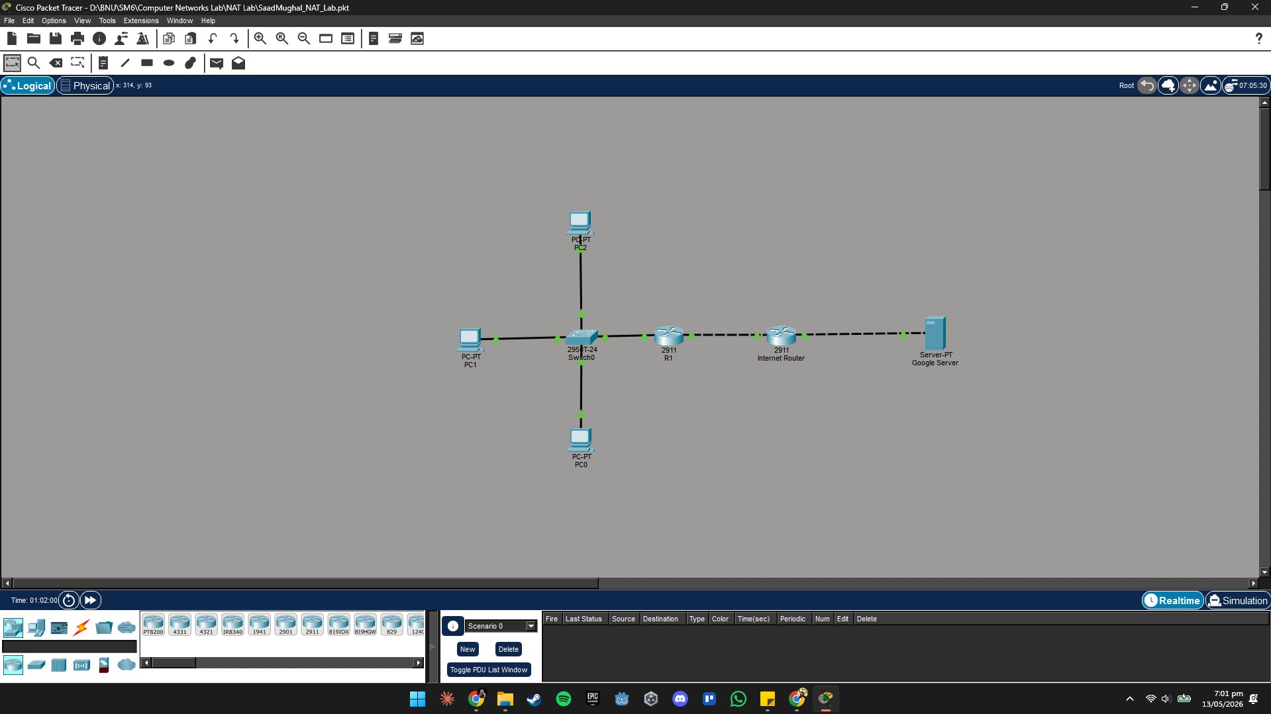

Task 1: Building the Core (4 Marks)
Configure interface IPs and establish connectivity between the routers. R1 must use a default route to "reach the internet."
# R1 Default Route
R1(config)# ip route 0.0.0.0 0.0.0.0 203.0.113.2
# INTERNET Router Return Route (CRITICAL)
INTERNET(config)# ip route 100.0.0.0 255.255.255.0 203.0.113.1
Instructor Note: The INTERNET router requires a return route for the NAT Pool (100.0.0.0/24) pointing back to R1. Without this, the server's reply will be dropped by the ISP.

INTERNET Router
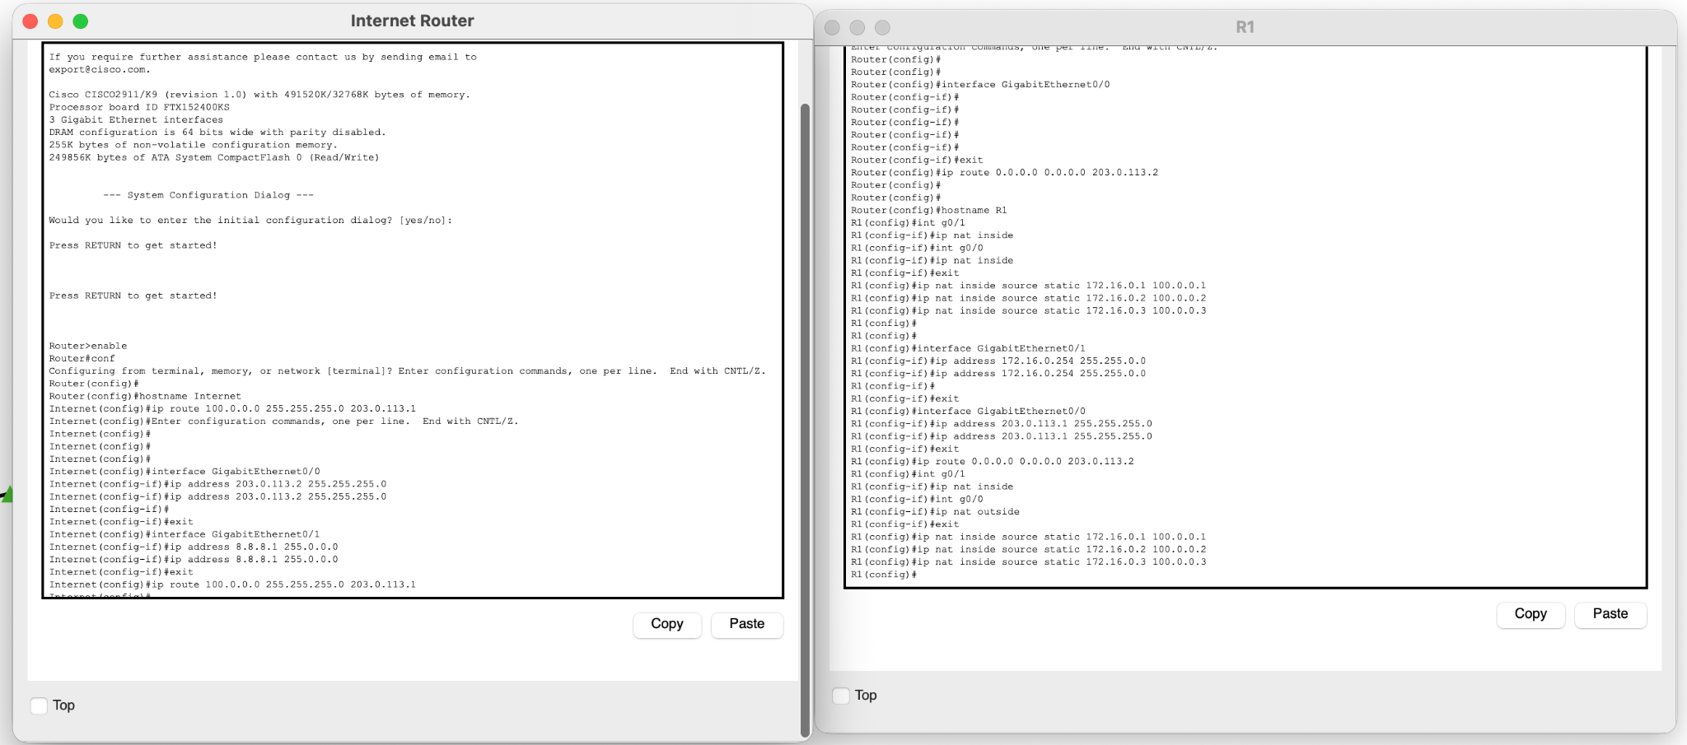
R1


Task 2: Static NAT Configuration (6 Marks)
Configure R1 to map each PC to a specific public IP. Designate NAT interfaces correctly.
R1(config)# int g0/1
R1(config-if)# ip nat inside
R1(config)# int g0/0
R1(config-if)# ip nat outside
R1(config)# exit
R1(config)# ip nat inside source static 172.16.0.1 100.0.0.1
R1(config)# ip nat inside source static 172.16.0.2 100.0.0.2
R1(config)# ip nat inside source static 172.16.0.3 100.0.0.3
Verification: Ping 8.8.8.8 from PC1. Screenshot the NAT Translation table using show ip nat translations.
PC0
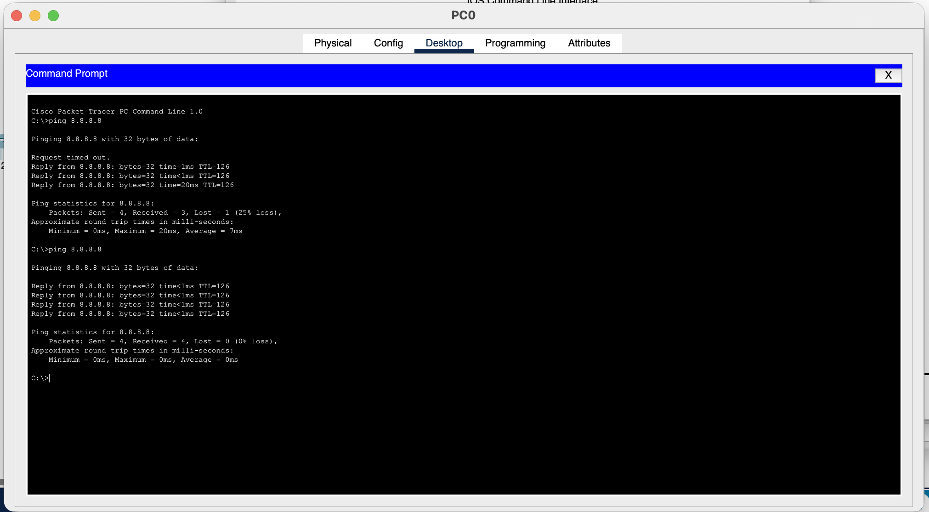
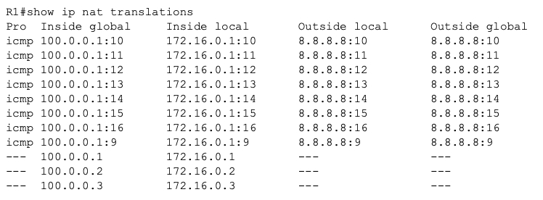
Task 3: Dynamic NAT Configuration (6 Marks)
Clear static rules. Set up a NAT pool of only 2 public IPs and bind it to an ACL for the LAN subnet.
R1(config)# clear ip nat translation *
R1(config)# no ip nat inside source static ... (Remove all 3)
R1(config)# access-list 1 permit 172.16.0.0 0.0.0.255
R1(config)# ip nat pool Pool1 100.0.0.1 100.0.0.2 netmask 255.255.255.0
R1(config)# ip nat inside source list 1 pool Pool1
Challenge: Start a continuous ping on PC1 and PC2. Then attempt a ping from PC3. Screenshot the failure and explain why it occurs.
PC2
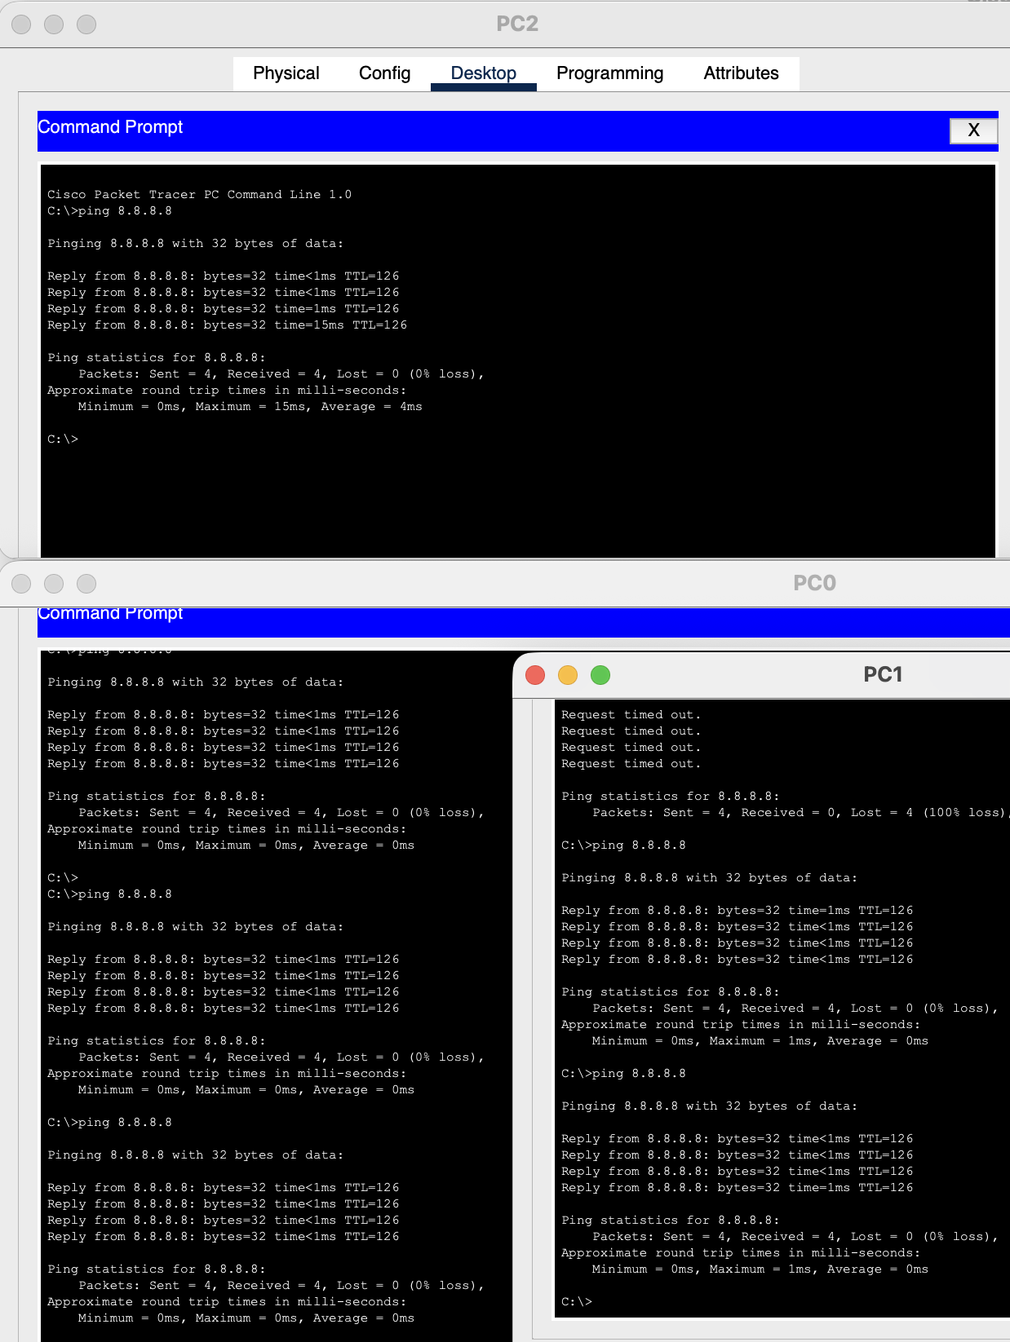
PC0

PC1

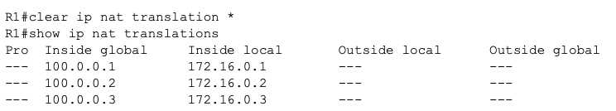
Task 4: Analysis & Understanding (4 Marks)
- When pinging 8.8.8.8, why do the first 1-2 packets usually time out?
Ans. The router must find the hardware (MAC) address of the next device before it can send the data. The ping times out while waiting for this brief "handshake" to finish.
- What does the "Gateway of Last Resort" represent in R1's routing table?
Ans. It is the router's default exit. If R1 receives traffic for a website or IP it doesn't recognize, it sends it to this gateway as a "last resort" to get it to its destination.
- Identify the Inside Global address in your Dynamic NAT translation table.
Ans. The Inside Global addresses are 100.0.0.1 and 100.0.0.2. These are the "public" addresses from your pool that the outside world sees when your private PCs are talking to the server.
Task Excellent (Full) Needs Improvement

Infrastructure (4) | Default & Return routes configured; pings succeed. | Pings fail due to missing routes.
Static NAT (6) | 3-way mapping verified with CLI table screenshot. | Incomplete table or incorrect interfaces.
Dynamic NAT (6) | Pool limits tested and failure on 3rd PC observed. | ACL/Pool syntax errors.
Analysis (4) | Correct technical terminology used in answers. | Answers are vague or missing.

Requirement | Status | Verification Command
Default Route | Configured | show ip route
Inside/Outside | Gi0/1 (In) / Gi0/0 (Out) | show ip nat statistics
Dynamic Pool | Pool1 (2 IPs) | show ip nat translations
ACL 1 | Permit 172.16.0.0/24 | show access-lists

